SUPERVISION
Date / time: 30/10/2025

Main issues discussed
1. Principles for research and writing
2. Process documentation and weekly report format
3. Initial materials and a “slow start”
4. Code, documentation, and “contribution to knowledge”

Work shown
- Present the performance of MiniRocket, MultiRocket, and TST on the LARa dataset.
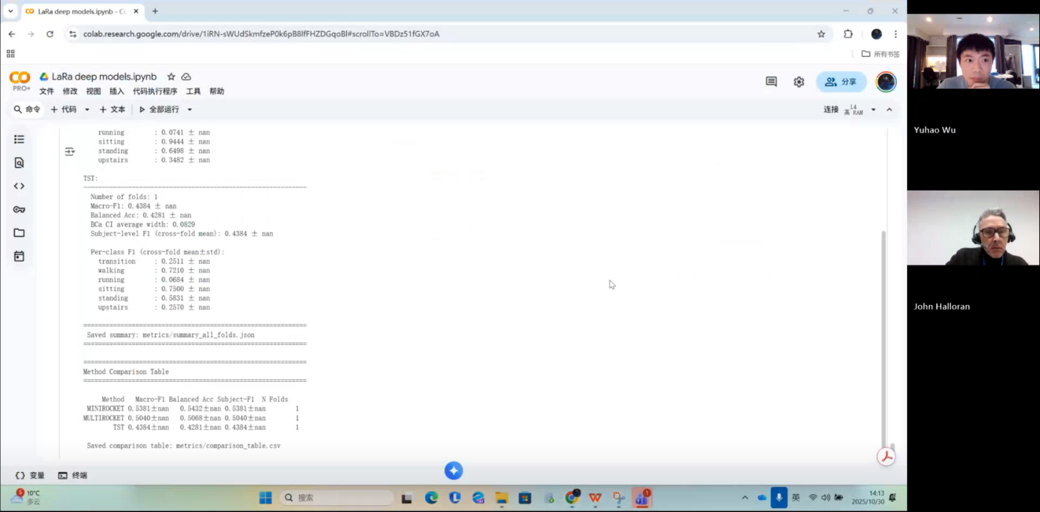

- I showed my weekly project progress template to my supervisor, Halloran.
Answer: No need to change anything else. Add action items at the beginning, and add next week’ s action items at the end.
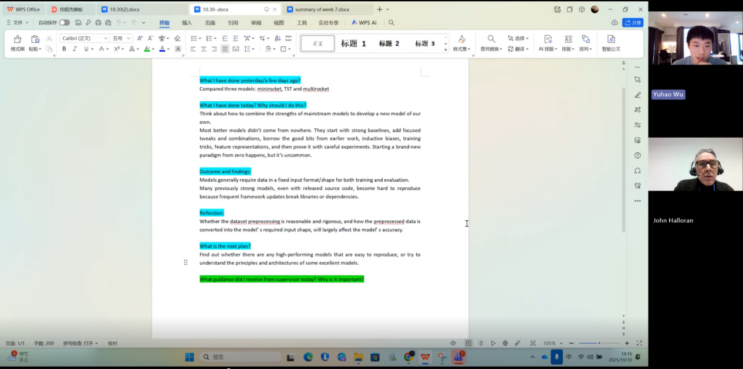

- Provide an in-depth, technically detailed explanation of how kNN, Random Forest, and InceptionTime work.
Answer: It is a good choice to explain how these models work in more detail and at a deeper level.
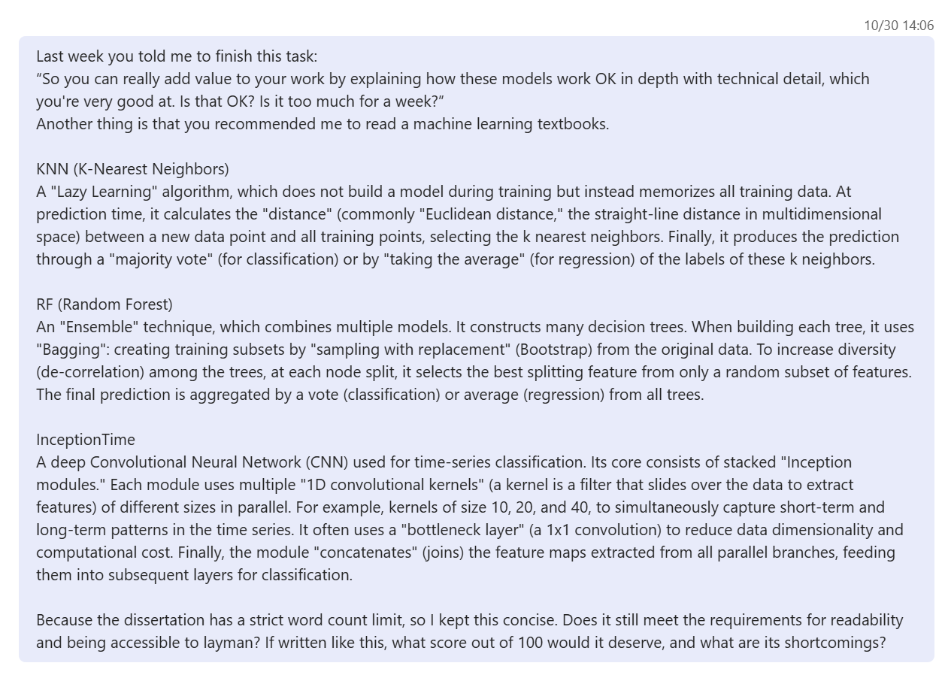

Questions asked; how questions were answered
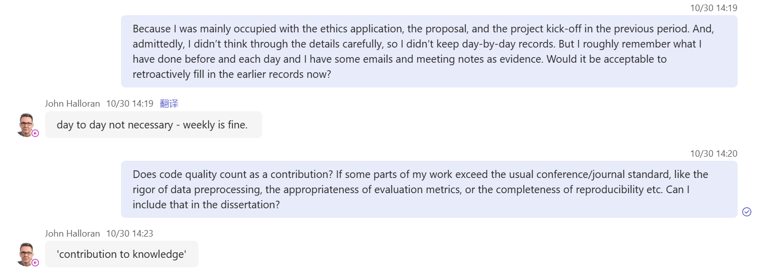
Answer
1. You don’t need to keep day-by-day records. Daily records are not required; doing it weekly is enough.
2. Yes, this is important. The technical quality of your work really matters, the technical part counts for 30% of your work.

Email
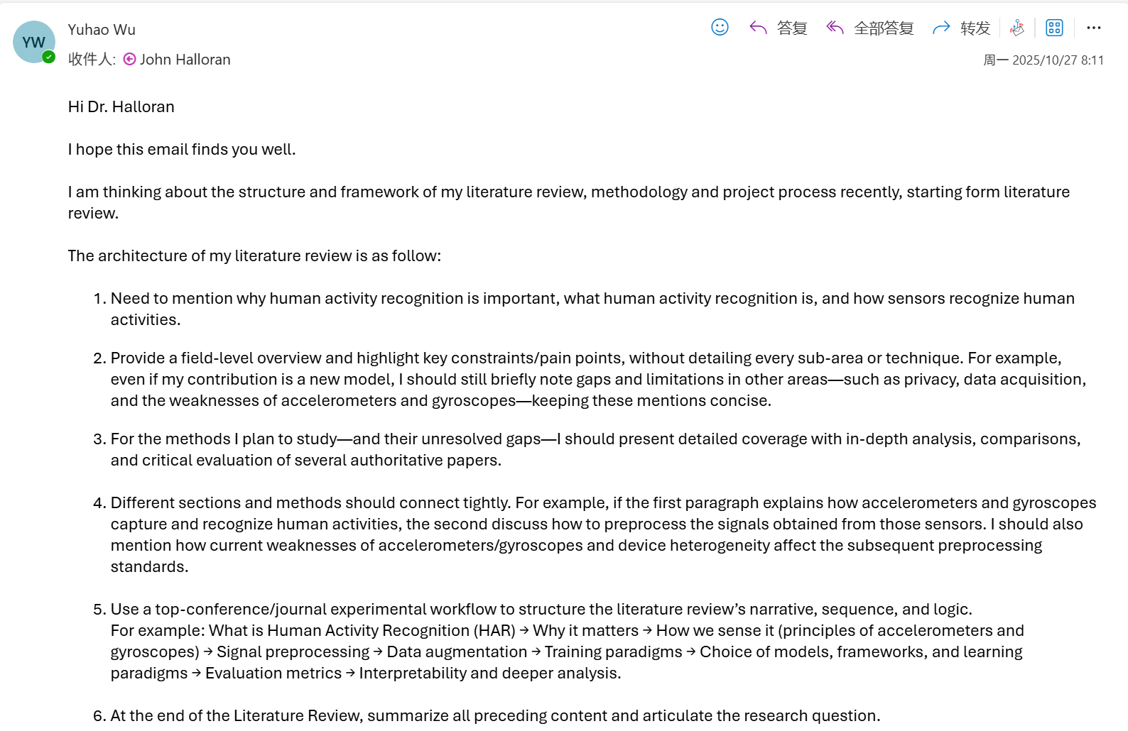
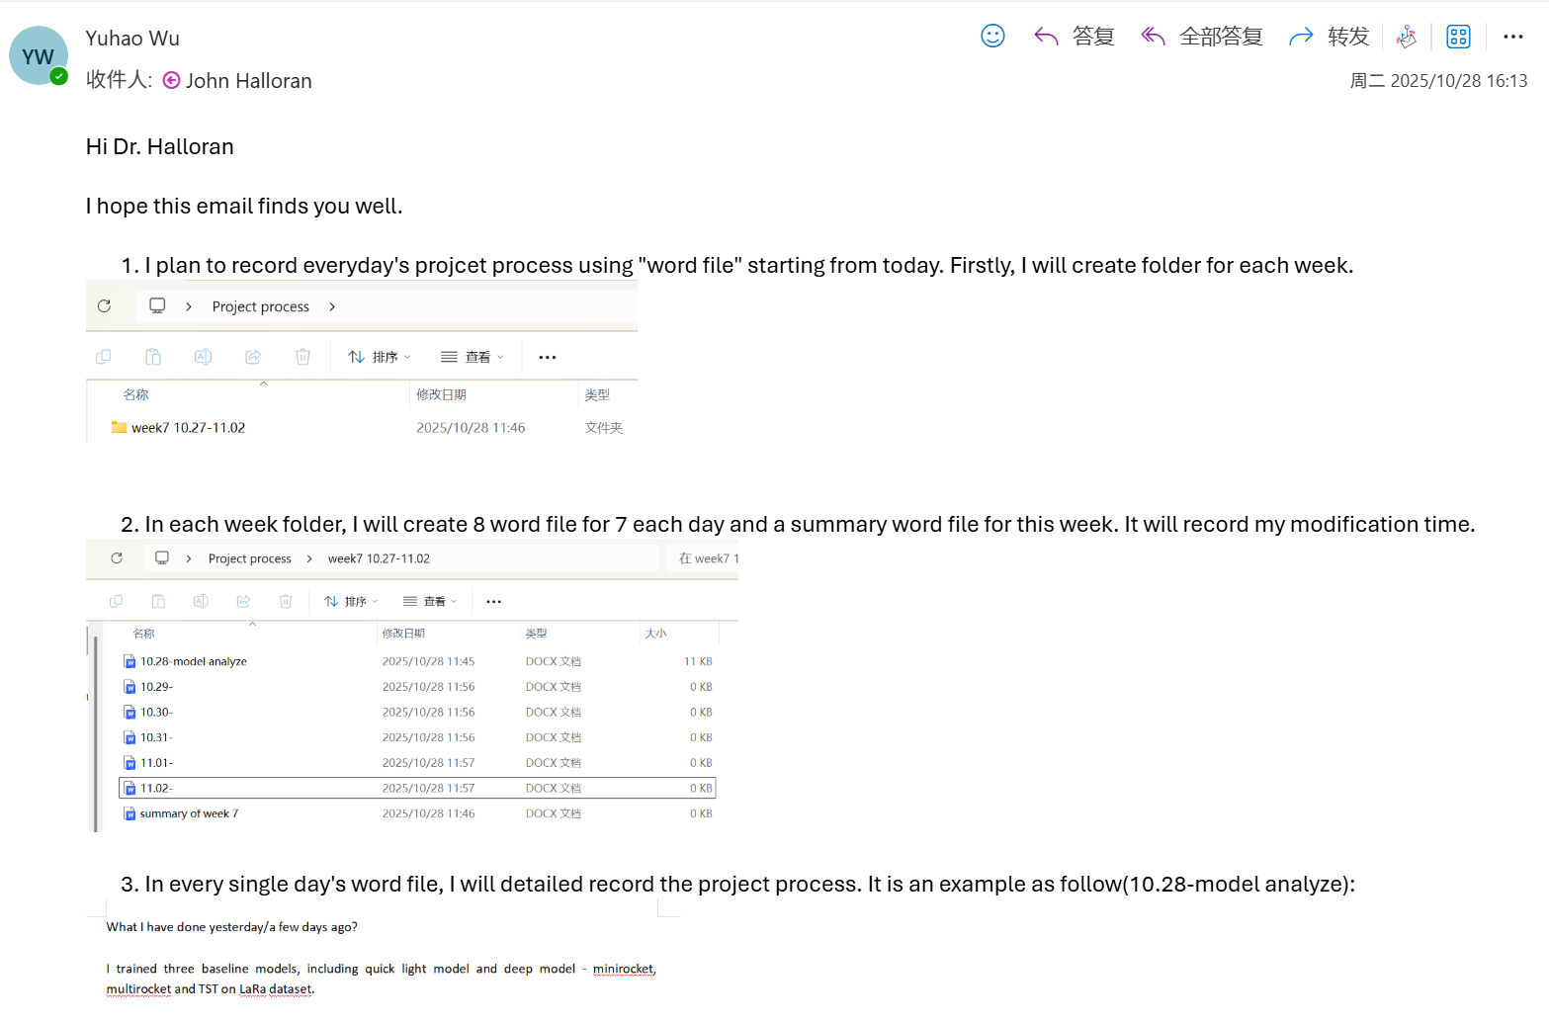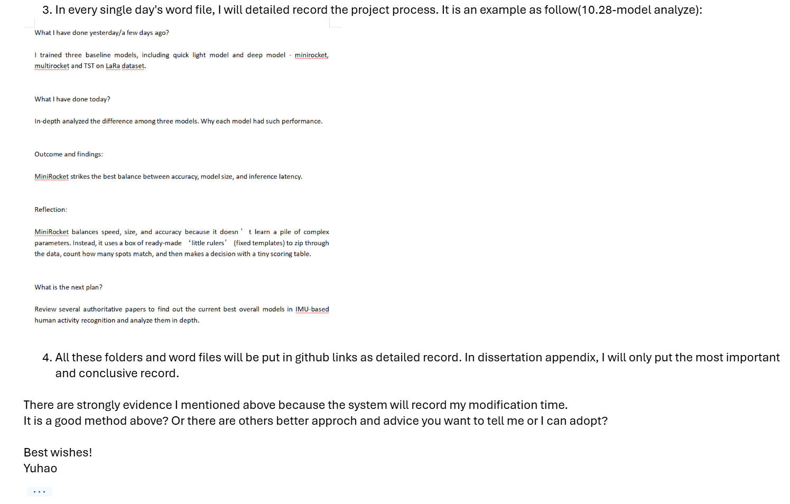

Computing Project
WORK DONE
1. Solve the problem of MultiRocket’s slow training speed on the RealWorld dataset.
2. Measure the energy consumption of the six baseline models.
3. Start designing a new model and add a state-of-the-art model as an additional baseline.
4. Read the machine learning book recommended by my supervisor.
5. Completed the sensitivity and robustness experiments for MiniRocket, and statistical analyses for other models.

Issues and challenges
The new model is quite difficult.

Actions for next week
1. Think about how to design a new model based on rTsfNet and show the experimental results to my supervisor next time.
2. Ask my supervisor whether solving the gradient explosion problem can be written up in the dissertation.

Evidence
https://livecoventryac-my.sharepoint.com/:v:/g/personal/wuy176_uni_coventry_ac_uk/IQD45v4X2lX4T7BqcGRptJ1fAUwDTWgQCiL4CquUKBRClwA?nav=eyJyZWZlcnJhbEluZm8iOnsicmVmZXJyYWxBcHAiOiJTdHJlYW1XZWJBcHAiLCJyZWZlcnJhbFZpZXciOiJTaGFyZURpYWxvZy1MaW5rIiwicmVmZXJyYWxBcHBQbGF0Zm9ybSI6IldlYiIsInJlZmVycmFsTW9kZSI6InZpZXcifX0%3D&e=uXAhZP

